Ergonomics and Safety
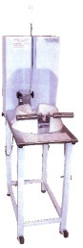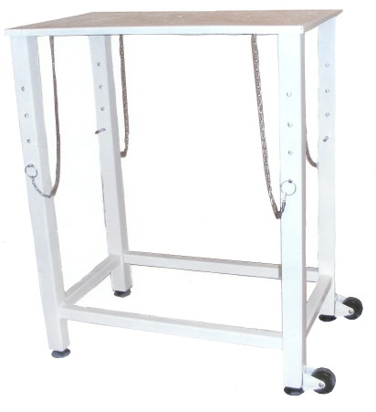

- Ergonomically designed to accommodate individual variances amongst operators – differences in size, strength, and food preparation versatility

- Choices in height settings for the Mobile Ergonomic Table customize the BIG FAT FRUIT & VEGGIE CUTTER™ to each individual operator, reducing load strain on the body by improving posture

- Reduces repetitive strain and upper limb injuries for shoulders, rotator cuff, arms, elbows, and wrists, as well as alleviating lower back stress and fatigue

- Promotes safety as the large cutting knife, mounted to a secure hydraulically-controlled housing apparatus, is never in contact with the operator. Compromising cutting conditions and possible human error causing injury are virtually eliminated.

- Easy operation and continuous use enhance efficiency, productivity, food quality, and personal job satisfaction

- Injury compensation claims are reduced

